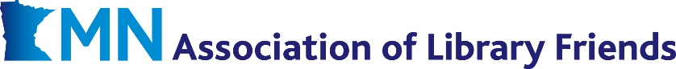
- GOOD NEIGHBOR GRANT -

Libraries are far more than buildings and books. They stand apart as uniquely responsive resource hubs. Within their public service mission, libraries have flexibility to adopt or adapt priorities matched to the real-time needs of their community.
Which needs are most acute? That varies community to community – and can change from month to month, as 2026 has already shown. Perhaps the only true universal is resource constraints: finite budgets and other means with which to respond to the community’s needs.
As communities across Minnesota navigate a year like no other, the Minnesota Association of Library Friends wants to empower Friends of the Library and their libraries to rise to the occasion. MALF’s new Good Neighbor Grant is making monetary grants up to $1,000 available to member organizations eager to support solutions to whatever problems loom largest in your community.
What’s the catch? There isn’t one. This program is, by design, broad and responsive in nature. A wide array of purchases and priorities are qualified for consideration, provided only that the priority identified involves the local library and centers a pressing community need. A non-exhaustive list of ideas includes…
- Collection Development: Our communities are increasingly diverse, both demographically and in terms of resident expectations for resources on offer through their library. Unfortunately for us all, library collection budgets are not keeping pace with rising material costs. A one-time Neighbor Grant could be an excellent way to muscle up your large print selection, Spanish language collection, children’s offerings, or any other collection need approved by your library.

- Outreach Efforts. Libraries are perennially challenged to reach and serve nonusers, yet often lack the budgetary wherewithal to make it a concerted priority. Support from a Good Neighbor Grant might be just what’s needed to expand school visits, hold off-site story times, support pop-up libraries, pay for advertisements, or table at a community event.
- Community Collaboration: Friends and their libraries routinely partner with area schools, social service and wellness agencies, senior and youth organizations, service clubs, local businesses, etc. on collaborations that would not be possible through just one party alone. A Good Neighbor Grant might be just what’s needed to expand an existing organizational partnership or forge a new one.
Eligibility Requirements
Eligible applicants are Friends of the Library organizations that:
- serve a Minnesota-based public, school K-12, college/university, or special library,
- are 501(c)3 public charities eligible to receive tax-deductible donations, and in good standing with the IRS and Minnesota Secretary of State,
- are current in their annual MALF membership dues,
- have pre-approval from their library to spend/allocate money awarded in the ways identified in this application, and
- agree to dispense these funds for their intended purpose no later than
Friday, July 31, 2026.

Application Procedures
Friday, May 1 is the priority deadline to submit your request for a ≤ $1,000 grant. MALF reserves the right to close that window earlier if requests outstrip program budget.
Applications must be submitted online via Google Forms. Be prepared to provide a 100–300-word answer to each of the following prompts:
- Describe the community need(s) you have identified and wish to address. What sector(s) of your community are you centering?
- Describe the project, initiative or program you wish to fund. Be as specific as possible.
- How would a monetary award from the Good Neighbor Grant program support the creation of that program (if new) or bolster existing efforts (if already established)?
- If you received a Good Neighbor Grant, how exactly would you spend the money? If applicable, provide a line item list of expected expenses.
MALF will notify all applicants of outcomes by no later than Friday, May 15, 2026.
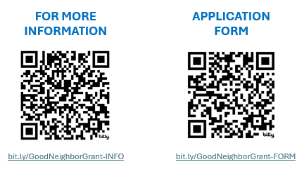
Direct questions about the Good Neighbor Grant program to info@mnlibraryfriends.org or 651-366-6492.

